3.67: Take 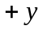 to be downward.
a) Use the vertical motion of the boulder to find the time it takes it to fall 20 m to the level of the surface of the water.
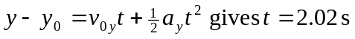
The rock must travel 100 m horizontally during this time, so
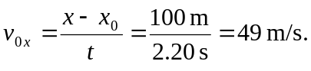
b) The rock travels downward 45 m in going from the cliff to the plain. Use this vertical motion to find the time:
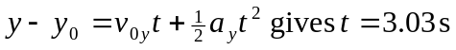
During this time the rock travels horizontally
The rock lands 50 m past the foot of the dam.

